*From <*[*http://journals.plos.org/plosone/article?id=10.1371/journal.pone.0147266*](http://journals.plos.org/plosone/article?id=10.1371/journal.pone.0147266)*>*

Can we potentially use different types of source localization algorithms?

Introduction

* Multiple areas of cortex expected to be active at the same time
* Current source density (CSD) models developed to overcome limitations of dipole models
  + DM: assume single / small no. of dipoles to represent source of EEG
* CSD show activity in multiple areas of cortex

* Aim: compare source localization algorithms when locating multiple simultaneously active cortical generators
* Studies:
  + Low resolution electromagnetic tomography (LORETA)
  + Minimum norm least square (MNLS)
  + Standardized low resolution electromagnetic tomography (sLORETA)
* Comparisons made on 2 things:
  + **Precision**: how many detected sources are real sources
  + **Recal**l: fraction of real sources found by algorithm

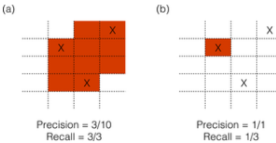

Evaluation of CSD results

* Algorithms had 2 goals (that were tradeoffs to each other):
  + Reconstructing all sources
  + Minimizing false positives
* Calculation of precision and recall
  + Active values on grid (see above) -> values that had strength higher than a strength threshold
  + Precision: calculated as no. of "correct" voxels divided by total no. of active voxels
  + Recall: no. of real sources that had active voxel / total no. of sources in stimulation.

Results

* With increasing strength threshold, algorithms become more conservative and only label smaller areas as active
* Increase in precision -> decrease in recall
  + All reconstructions for methods follow this trend

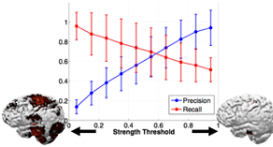

* Ideal algorithm would have perfect precision if 1 and perfect recall of 1
* When there's only one active source, all algorithms perform well (rarely any false positives)
  + sLORETA performs best
    - Precision: 0.93, recall: 1 for all strength thresholds
    - Others have lower precision
* With >1 sources simultaneously active, trade off is apparent btw precision and recall
  + sLORETA precision drops more steeply than other algorithms
  + LORETA 1.5 has best combined performance (because of recall values)

± 0.7 
- •-sLORETA 
LORETAI 
LORETA 1.5 
LORETA 2 
MNLS 
Number Of Sources 